I have developed multiple apps from scratch and have followed SOLID principles all the time. I think this needs to be followed for all the apps that we develop as it

enables us to create quite clean code that is easy to understand and easy to change. Basically in simple words these principles tell us how

to arrange our functions and data structures into classes, and how those classes should work together.

Example -

We have followed Single responsibility principle to design the project structure where each layer is designed only for one responsibity.

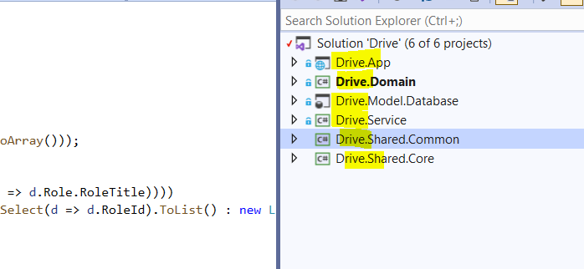

This enabled us to create smaller, cleaner, and thus easier to maintain classes.

Also I have implemented other principles according to the requirements in the code.